A day at Livsmedelverket

Imagine that you are done with your studies in Chemistry, and you got a job at Livsmedelverket. In your new job it is your duty to ensure that all legal standards are met during the production of food. You got an anonymous hint that in a winery, something is not done properly. You already checked the winery and took three bottles of wine with you, to find out if the wine is ok. In your laboratory you have access to X-ray fluorescence, Infrared-absorption, Raman-spectroscopy, UV-Vis absorption and NMR. How to proceed?

- Discuss what determines the wine’s quality
- Decide which spectroscopic methods to use
- Analyze the spectra
- Make a report about the wine

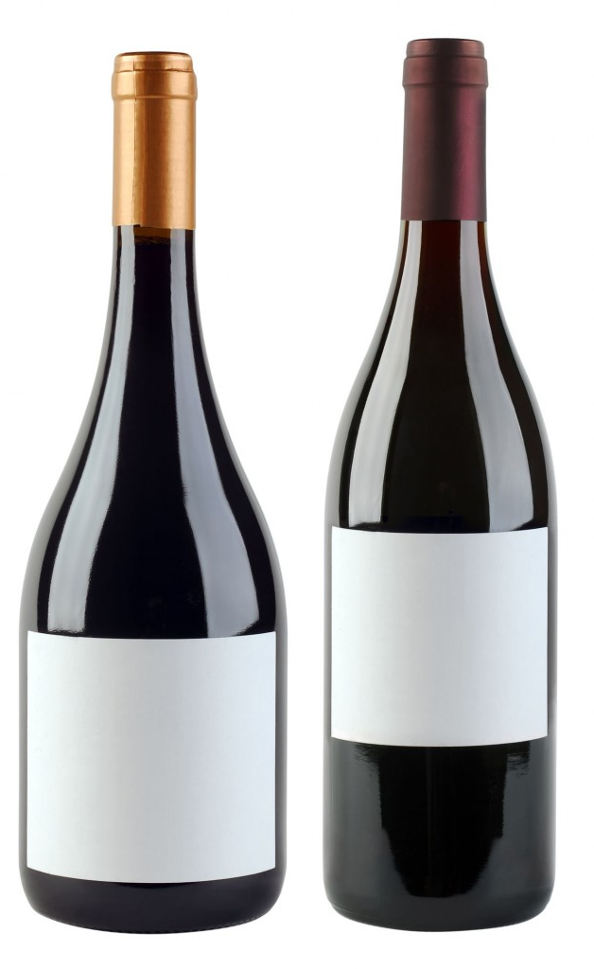
A
B

